Lab – 2 – GIT & GITHUB
PART 1:
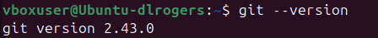
Step 1: Start by installing Git on your machine. Verify its installation by checking the version (Add screenshot)

Step 2: Set your username, e-mail, and editor by running the following commands:

git config --global user.name “your-name”

git config --global user.email “your-email”

git config --global core.editor “any-editor”

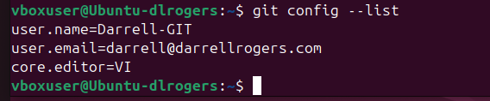
Run the command to check all the information you set. The output should look like this: (Add screenshot)

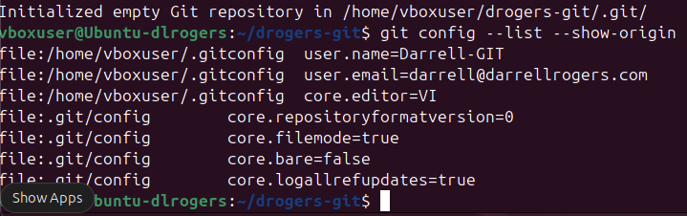
Step 5: Which directory git uses to track all changes? Run the command for it. (Add screenshot)

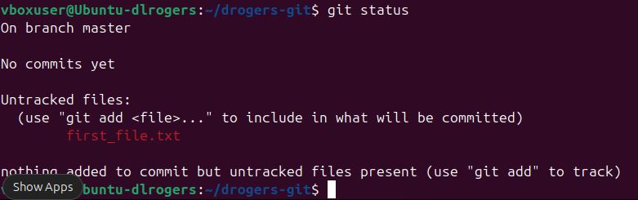
Step 7: Run the command: git status (Add screenshot)

Two theory questions follow:

Q) Explain the output?

I am on branch master, no commits have been made and there are untracked files.

Q) Explain the three-tree architecture in Git?

Git manages our data using trees. Each represents a state. There is the working directory, the staging area and the actual repo or HEAD. Each is an integral part of the workflow: You create / edit, you stage, you commit.

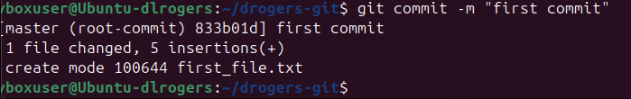
Step 8: Run: git commit -m “first commit” (Add screenshot)

Step 9: Two theory questions follow:

Q) Explain in detail what is SHA value in Git?

The SHA is a calculated value based on the content of the commit. It includes the files, the author the date and message. Any changes to these data elements will cause a change the SHA value.

What is the SHA value in your previous output?

00a7f09e031b8bac9afafde56a96af17b1a2ea90

Q) Explain what HEAD is and what is a master?

In Git it is a symbolic reference that points to the current branch’s latest commit. The master is the term used to define the default branch created in a repo.

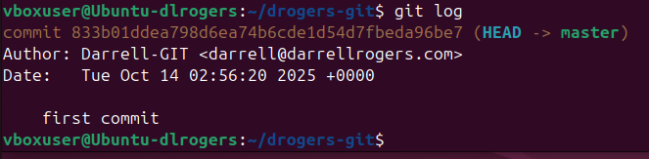
Run a command to see and check where the head is pointing (Add screenshot)

PART 2:

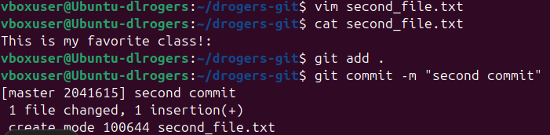
Step 1: Make a second file named second_file.txt and add any text to it. Perform Git Add and commit this file (Add screenshot)

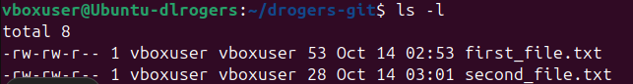
Step 2: Run the command to view the change you made. (Add screenshot)

The theory question follows:

Q) Explain the output seen in above SS? – anything written about GIT DIFF command.

The Git diff command will show any changes made after editing a file.

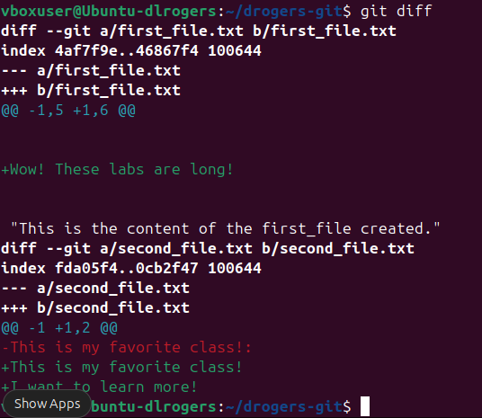
Step 4: Run the command to see the changes you made in both files (Add screenshot)

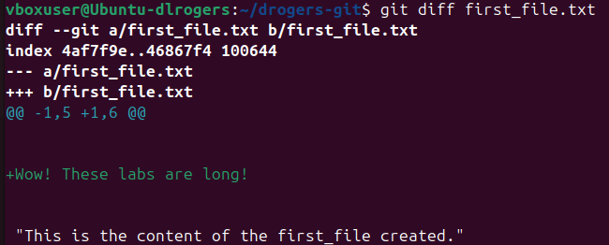
Step 5: Now run the command to see only the change you made in the first file (Add screenshot)

GitHub

•Working Remote

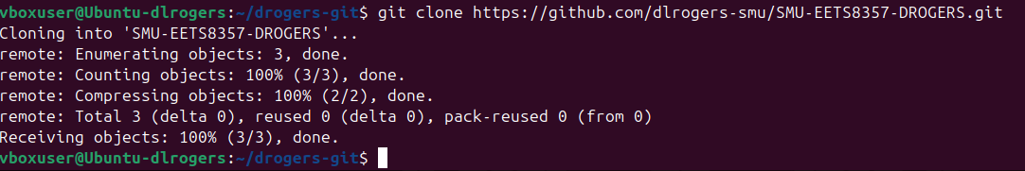
Step 2: Clone this repository in your local machine and navigate into that directory. (Add screenshot)

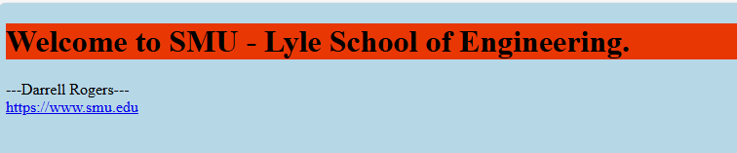
Step 3: Create a new index.html file such that it should give the following output: (Add screenshots)

Step 4: Now go back to your HTML file and add an image that would give an output like the following: (Add screenshot)
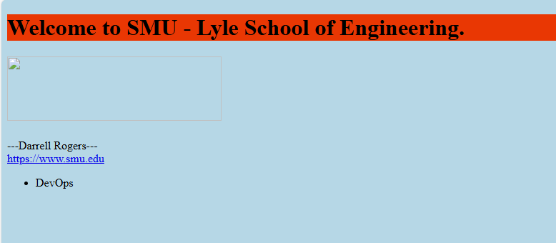

Step 5: Now after committing the previous change, we want to undo it. Revert to the original index file without the image (Add screenshot)


•Branching, Merging, And Merge Conflicts. The theory question follows:

What is a branch, and which is the default branch?

Git creates a default branch that is it’s own timeline of commits. Changes made to one branch do not impact other branches. The default branch is the primary branch where all production ready code is migrated to.

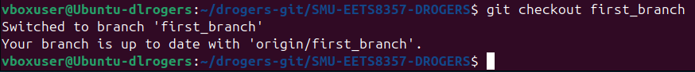
Step 1: Now create a new branch off master named the first_branch. Run the command to check which branch you are in currently. (add screenshot).

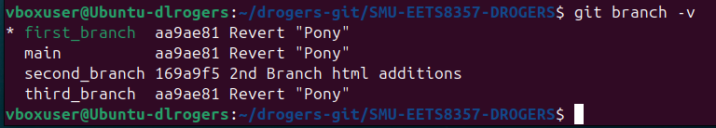
Run the command to check where is the new branch you created. (add screenshot).

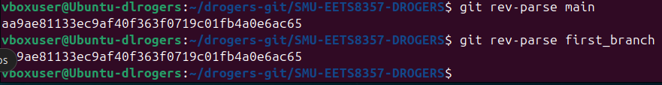
Run the commands to check where is head pointing for both branches.(add screenshot)

Q) Is the head different or the same? Explain your output.

In this case it is the same since I have done no changes for each branch. Normally, HEAD is different for each branch because it will always point to the latest commit in the current branch. When you switch branches Git moves the HEAD point to the commit history of that branch and is how our working directory switches to the branch contents.

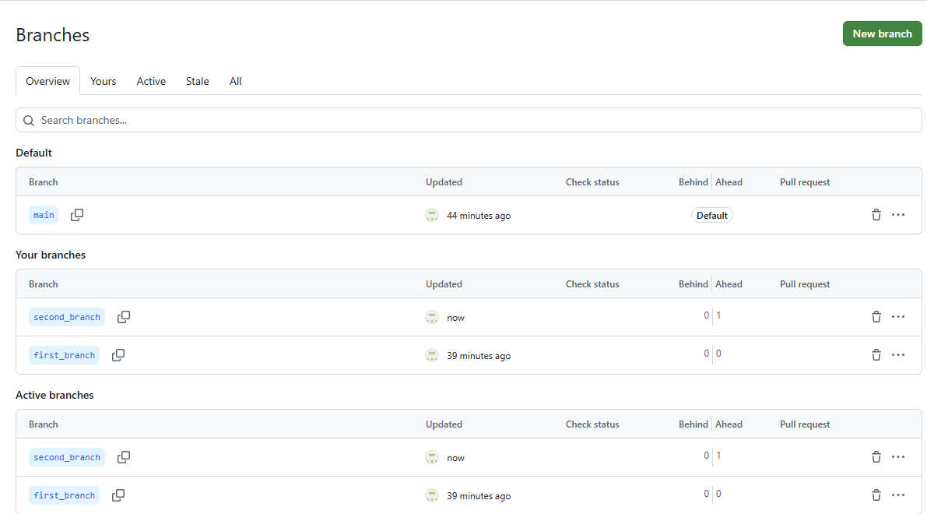
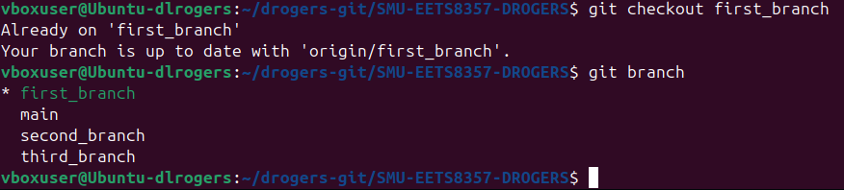
Step 2: Change your branch to the new branch, verify that you have changed it correctly, and push it to your remote repository. (Add screenshots)

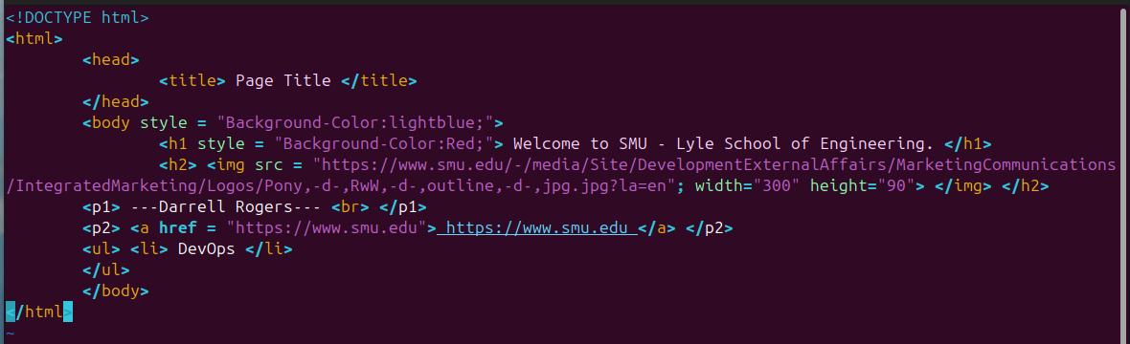
Step 3: Now go to the index.html file and add a link (https://www.smu.edu/) to the index.html (add screenshot)

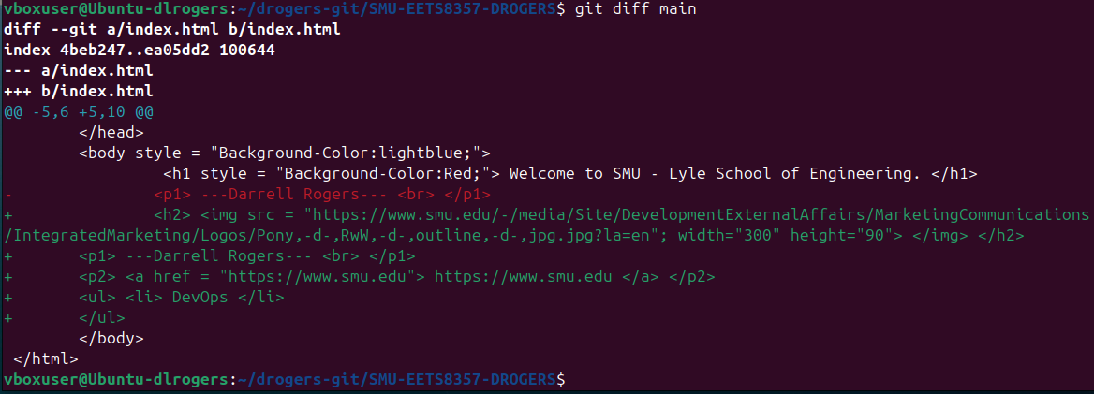
Check whether the changes you made in your index.html file have been made successfully. (Add screenshot)

Step 4: Now create a new branch named the second_branch and switch to that. (Try doing this with just one command) (add screenshot)

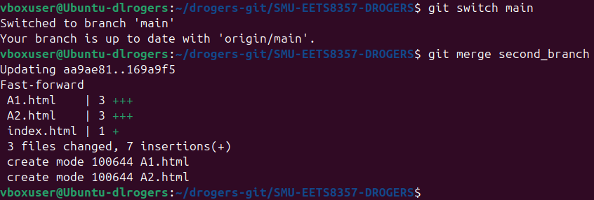
Step 6: Now merge your current branch with a master branch. (Add screenshot)

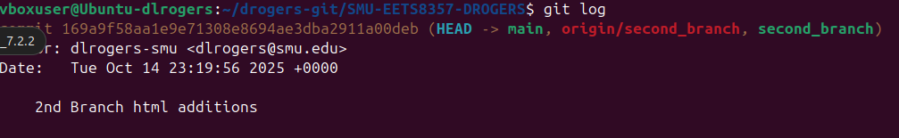
After merging, run the command to check where is head pointing. (Add screenshot)

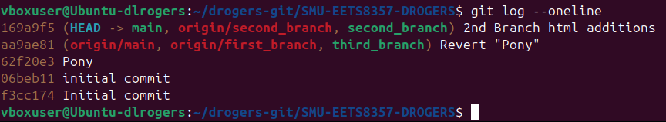
Run the command to check if you have successfully merged both branches (Add SS)

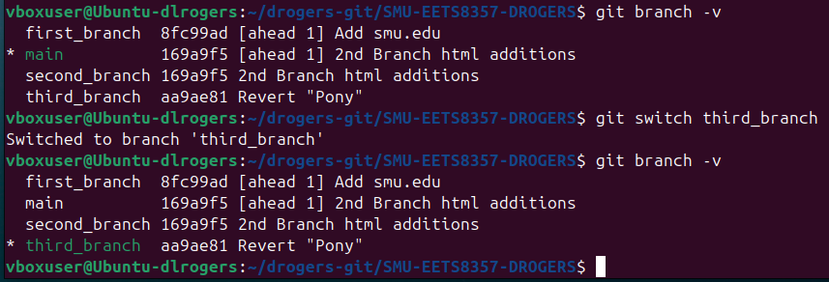
Step 7: Switch to your master branch and create a new branch called the third_branch and switch to that. (Add screenshot)

Was it there? If not, explain.

No, I have not merged the third branch and the master branch.

Step 8: Now merge your new branch with the master. (Add screenshot)

Was it successful? No.

Step 9: Explain what merge conflict is and resolve the error you got in the previous step. (Add screenshot)

I had to Git add . <fixed-files> and git commit.

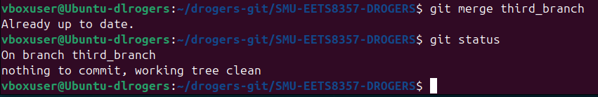
After resolving, merge again and it should be successful. (Add screenshot)

Explain different ways to resolve a merge conflict? A conflict arises when Git cannot automatically combine changes because the same parts of a file were modified differently between two branches. It has to be manually resolved to complete the merge. There are also Merge Tools that are integrated into the IDE we choose. You could also give a preference when conflicts arise to a certain branch and it will default to the preferred branch and merge.

Create a repository with three branches (1, 2, 3), and file-a exists in all three branches. File-b exists in branches 1 and 2, and file-c exists in branch-3.

Explain the behavior/outcome if you switch to any of these branches and then delete the local git repo.

If you switch to any one branch and delete the local git repo you will only retain the visible files from the most recent checked-out branch and there will no longer be a Git repo.

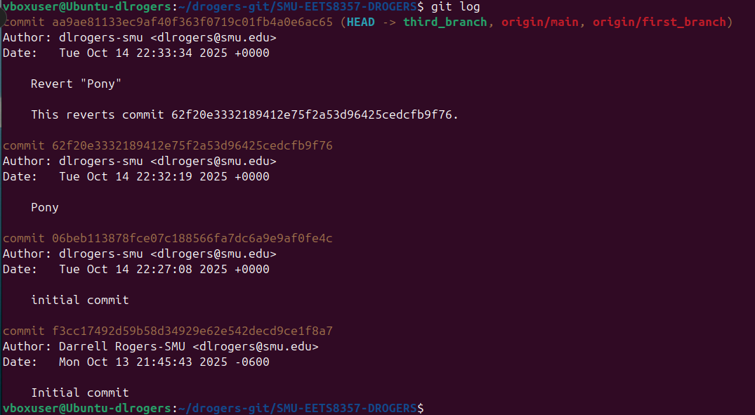
Paste the whole output of the “git log” after your last task in this Section. Screenshots should have a log of every task you performed.

